**\*\*\*\*\*\*\*\*\*\*\*\*\*\*\*\*\*\*\*\*\*\*\*\*\*\*\*\*\*\*\*\*\*\*Lab 2\*\*\*\*\*\*\*\*\*\*\*\*\*\*\*\*\*\*\*\*\*\*\*\*\*\*\*\*\*\*\***

**Lab 2.1 Follow the steps to Create a S3 Bucket and upload the file into the bucket**

Step 1: Choose S3 under storage service and click on Create Bucket button

Step 2: Provide a Bucket Name and choose the Region

Step 3: Click on Next

Step 4: Don’t change anything in SetProperties window and click Next

Step 5: You can add one more Account and click on Read permission click on Save button

Step 6: If you want give the public read permission to this bucket and click on Next

Step 7: Review it and click on Create Bucket button

Step 8: Close this window and see your Bucket from list

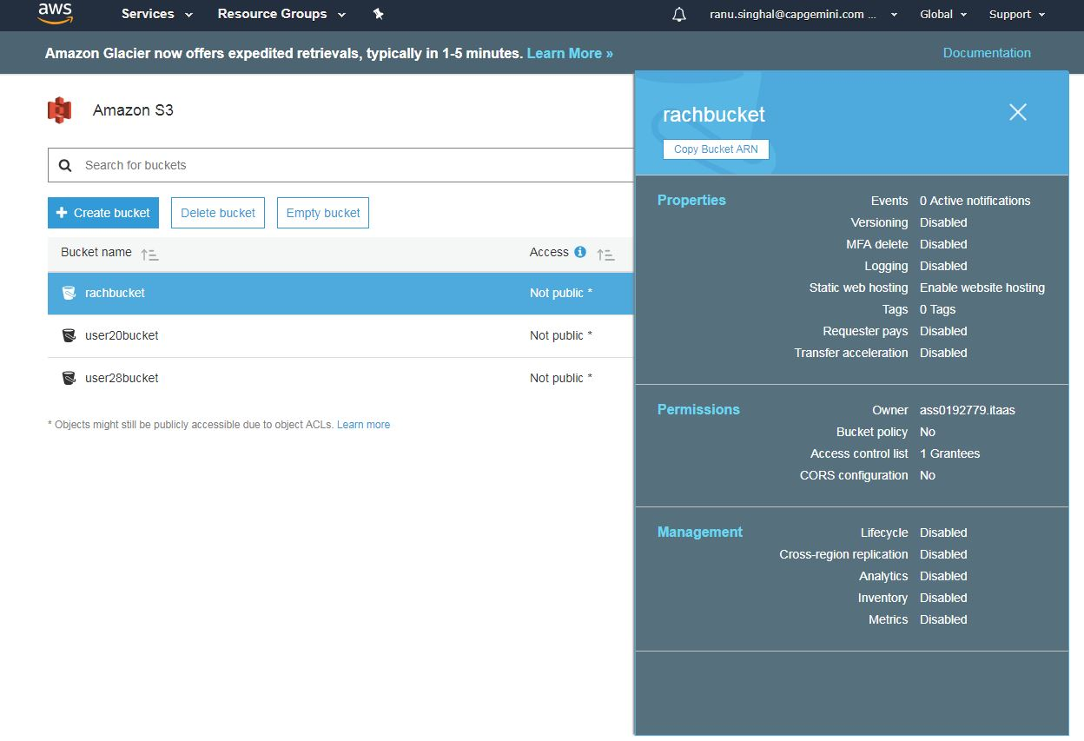

Step 9: Click on your Bucket and go to properties tab

Step 10: Click on Static web hosting tab

Step 11: choose “use this bucket to host your web site “

Step 12 : Provide the index document name and click on Save button

Step 13 : Come to Overview tab and choose a file and upload it

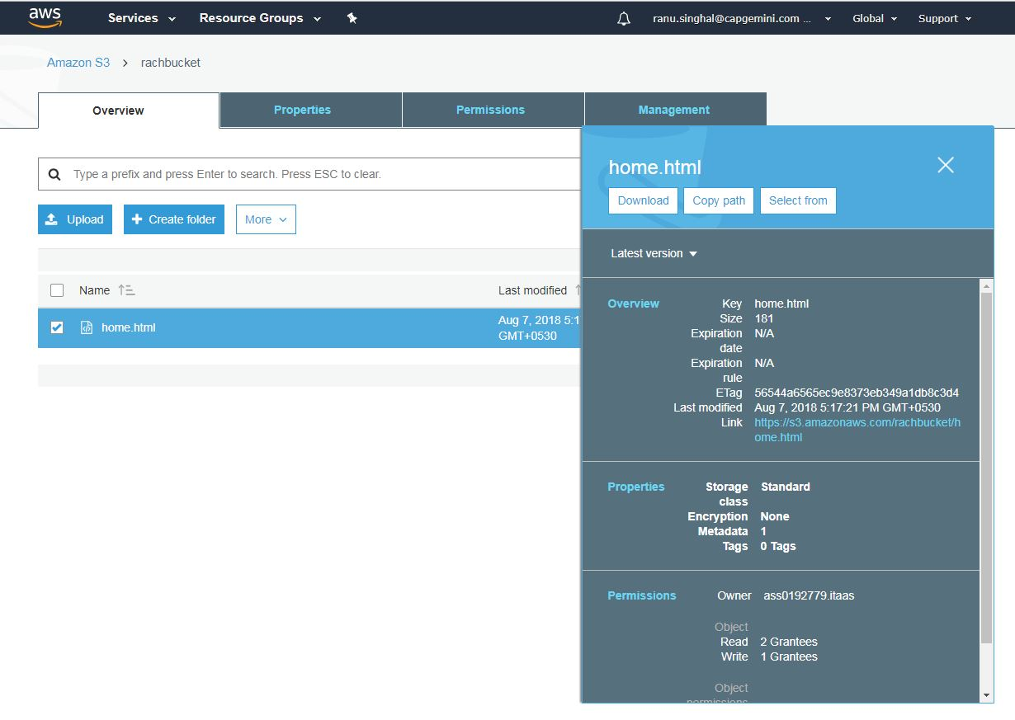

Step 14 : Click on the file you uploaded

Step 15 : Click on make public button

Step 16: Click on the link and see your file

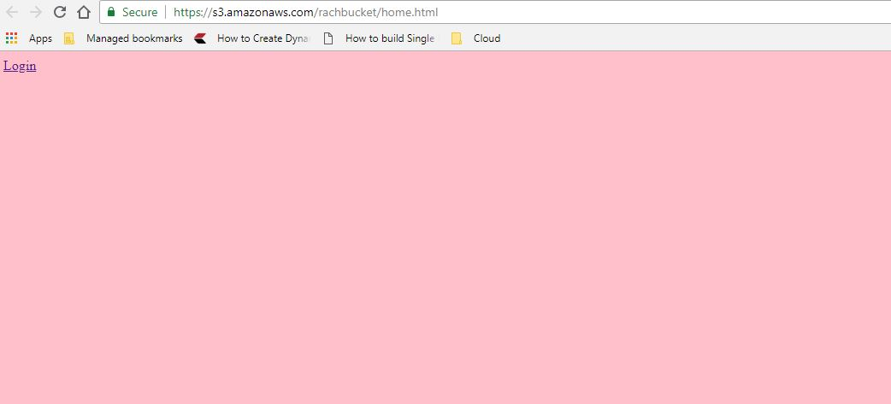

**Lab 2.2 Create an EBS Volume and attach to the existing EC2 instance and mount this secondary volume to store data.**

Step 1: Go to EC2 dashboard and click on Volume

Step 2: Click on Create volume

Step 3: Select Volume type and Add a Tag

Step 4: Click on Create Volume button

Step 5: Select the volume and attach it

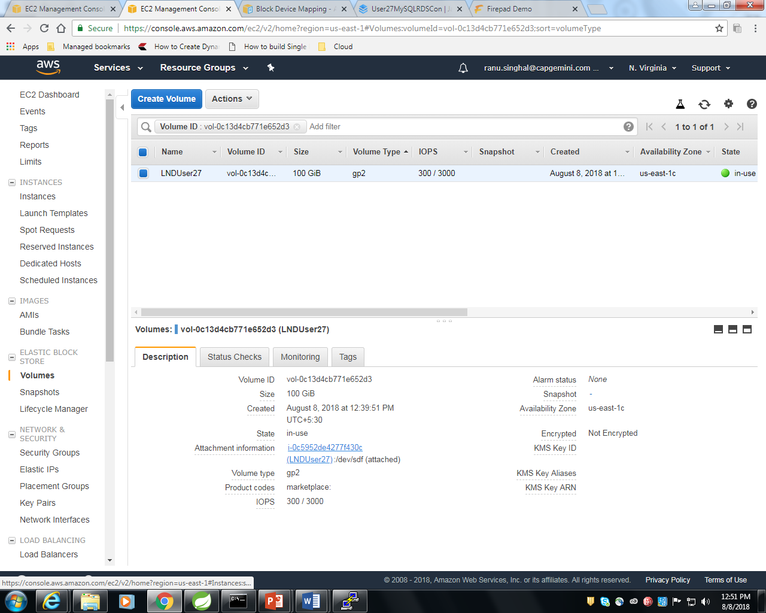

Step 6: Note the Linux Device path

Step 7: Click on Attach button

For Mounting your Volume , Go to Putty and type the below command

Step 1: lsblk

Step 2: sudo file – s /dev/xvdf

Step 3: sudo file –s /dev/xvda1

Step 4: sudo mkfs -t ext4 /dev/xvdf

Step 5: sudo mkdir /data

**Putty Commands Run:**

**[ec2-user@ip-172-31-81-202 ~]$ lsblk**

NAME MAJ: MIN RM SIZE RO TYPE MOUNTPOINT

xvda 202:0 0 8G 0 disk

└─xvda1 202:1 0 8G 0 part /

**[ec2-user@ip-172-31-81-202 ~]$ sudo file –s /dev/sdf**

/dev/sdf: symbolic link to xvdf

**[ec2-user@ip-172-31-81-202 ~]$ sudo file –s /dev/sda1**

/dev/sda1: symbolic link to xvda1

**[ec2-user@ip-172-31-81-202 ~]$ sudo mkfs -t ext4 /dev/xvdf**

mke2fs 1.42.12 (29-Aug-2014)

Creating filesystem with 26214400 4k blocks and 6553600 inodes

Filesystem UUID: 99355927-fdd2-4205-b2bf-99cbe105eef0

Superblock backups stored on blocks:

32768, 98304, 163840, 229376, 294912, 819200, 884736, 1605632, 2654208,

4096000, 7962624, 11239424, 20480000, 23887872

Allocating group tables: done

Writing inode tables: done

Creating journal (32768 blocks): done

Writing superblocks and filesystem accounting information: done

**[ec2-user@ip-172-31-81-202 ~]$ sudo mkdir /data**

**[ec2-user@ip-172-31-81-202 ~]$ lsblk**

NAME MAJ: MIN RM SIZE RO TYPE MOUNTPOINT

xvda 202:0 0 8G 0 disk

└─xvda1 202:1 0 8G 0 part /

xvdf 202:80 0 100G 0 disk